EE4704 CA1

(A) Image quality

1. This is a gray-scale image of a small hut surrounded by trees in daylight. The wall of the hut is dark, and it takes up the majority area in the image. The image is contaminated with Gaussian noise, and no salt-and-pepper noise is observed in the image. The image is considered quite sharp as the edges are generally clean. The details of the image are not very distinguishable, especially at darker regions. The image is very dark overall. Now, an intensity profile for the part in blue is generated below:

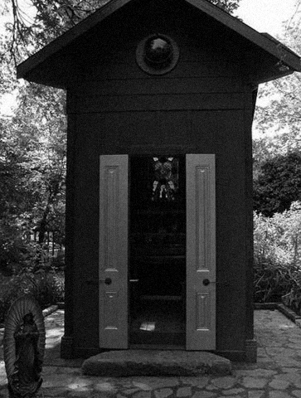

Figure 1: Intensity profile of the image

The intensity profile of the image is supposed to be generally uniform, but due to noise, we can see the profile is fluctuating a lot.

1. Histogram of the image



Figure 2: Histogram of the image

The histogram of the image is left shifted, which is under expectation as the image is dark. The left-most curve in the histogram corresponds to the hut as it is the darkest area in the image. The second left-most curve could be the small decoration at bottom left, the darker parts of the trees and the ground. The small peak on the right could be due to the doors and some brighter parts of the trees. The right-most peak at the right corresponds to the sky.

1. Apply histogram equalization



Figure 3: Comparison of test1.bmp before and after histogram equalization

After applying histogram equalization, the image became brighter in general. We can now see more details of the image in the darker area like inside the hut and the decoration at the bottom left. However, at the parts that are already bright in the original image, a huge amount of detail is lost like the cobblestone ground and some parts of the tree.

In the processed image, we can still observe Gaussian noise, and it is more obvious now as the image is brighter. This means that histogram equalization is not effective against Gaussian noise. Several reasons behind this are:

* 1. Histogram equalization works by redistributing the pixel intensities and thus increase the contrast of the image. This can improve visibility of image details and structures. However, this contrast enhancement may not be suitable when the image already contains Gaussian noise as it would make the noise more visible.
  2. Applying histogram equalization to an image with Gaussian noise can accentuate the noise. The equalization process tries to redistribute pixel intensities evenly across the entire range, including the noise values, which can make the noise more prominent and may lead to undesirable artifacts.

Gaussian noise is a common type of noise in images, and there are other image processing techniques that are more effective at reducing or removing noise, such as Gaussian smoothing (low-pass filtering) or various denoising algorithms (e.g., median filtering, wavelet denoising).

In summary, while histogram equalization can be a powerful tool for enhancing image contrast in certain situations, it is not well-suited for images that already contain Gaussian noise. When dealing with noisy images, it's important to consider noise reduction techniques before or in conjunction with contrast enhancement methods to achieve the best results.

(B) Image Enhancement

3. a = 1.2, b = -10



Figure 4: Image and histogram before and after applying transformation with a = 1.2 and b = -10. Mean (m): 188.11, Mu2: 1872.97, Mu3: -26045.74



Figure 5: Plot of mean vs a

‘a’ is the scaling factor. As ‘a’ increases, the mean tends to increase as well because the intensity of all pixels is scaled to a larger value. A scaling factor less than 1 will decrease the intensity of the pixels, and vice versa for scaling factor larger than 1. At ‘a’ = 1, the image should look exactly like the original image as the transformation has no effect on the image. As the scaling factor affects the intensity of all pixels, we can observe a darker image for ‘a’ < 1 and a brighter image for ‘a’ > 1.



Figure 6: Plot of µ2  vs a

µ2 is a measure of image contrast as it presents measures how the pixel intensities in the image are spread out around the mean. If the pixel values are widely spread out from the mean, µ2​ will be large, indicating high contrast as it implies that the image contains areas with significant variations in intensity, such as edges and textures.

Scaling the pixel intensity with ‘a’ causes all pixels to be scaled at the same factor. Initially, as you increase the value of a, you are effectively increasing the contrast of the image. This means that the differences between pixel intensities become more pronounced, and there is a wider range of intensity values. At a certain point, increasing aa further may leads to a peak in µ2​, indicating the maximum possible contrast achievable for the given image and transformation. Beyond this point, additional increases in aa may result in pixel intensities becoming too spread out, causing some values to reach extreme ends of the intensity scale (0 or 255 in an 8-bit image), which can lead to loss of information and clipping. As pixel values start to clip (exceed 0 or 255), it can cause a decrease in µ2​ because the spread of intensities is reduced when values are clipped.

This aligns with the observation from the images. As µ2 increases, the contrast of the image increases and there is no clipping. At ‘a’ = 1.2, the image reaches its peak contrast and µ2 decreases with increasing ‘a’ beyond that point. The clipping of the image begins when at ‘a’ = 1.1, indicating that there are already some pixels exceed the value of 0 or 255.



Figure 7: Plot of µ3 vs a

The third central moment µ3​ is a statistical measure that quantifies the skewness or asymmetry in the distribution of pixel intensities in an image. It provides information about the shape of the intensity distribution and whether it is skewed to one side or the other.

From the graph, µ3 is always negative, it indicates a negatively skewed intensity distribution which can be observed from the histogram of all images. In this case, there is a concentration of pixel intensities towards the higher end of the intensity scale, and there are relatively few low-intensity values. This situation is often associated with brighter or highlighted regions in the image. However, for ‘a’ < 1, the image appears darker than original image as although the histogram is skewed to the right, the overall intensity of the pixels is still very low. When ‘a’ > 1, we can observe some regions that are more highlighted as compared to original image. ‘a’ also affects the spread of the histogram. When ‘a’ is greater than 1, it effectively stretches the histogram. This means that the range of pixel intensities becomes wider, and the distribution of values spreads out. As a result, the histogram becomes wider, indicating increased contrast. The bright regions become brighter, and the dark regions become darker. Conversely, when ‘a’ is less than 1, it compresses the histogram. The range of pixel intensities becomes narrower, and the distribution of values condenses. The histogram becomes narrower, indicating decreased contrast. Bright regions become less bright, and dark regions become less dark.



‘a’ = 0.5 ‘a’ = 1



‘a’ = 1.1 ‘a’ = 1.3

Figure 8: Image and histogram for a = 0.2, 1, 1.1 and 1.3



Figure 9: Original image

The histogram of the original image is skewed to the right, with almost zero pixels below intensity of 75. Hence, I tried to stretch out the graph to make the pixels more evenly distributed by scaling the pixels with a = 1.2. By scaling up the pixels, the overall intensity of the image will increase, and since the original image is already bright, I let b = -10 to avoid clipping of pixels with high intensity.



Figure 10: a=1.2, b =-10

From the graph, we can obverse that there is still clipping of pixels with intensity more than 255. This indicated that we need to decrease the overall intensity of the image. Since in this case we want to increase the contrast of the image, which this transformation formula can only be achieve by increasing ‘a’ value, we should decrease the overall intensity by using a more negative b value instead of decreasing ‘a’.



Figure 11: a = 1.2, b = -30

Here, we can observe that there is much less clipping, but the contrast of the image is still not ideal. Therefore, I attempt to increase the contrast by increasing ‘a’. To prevent clipping, I also further decrease ‘b’ value.



Figure 12: a = 1.4, b = -40



Figure 13: a=1.5, b = -75



Figure 14: a=1.8, b=-90



Figure 15: a = 2, b = -110

Even though the contrast and the edge in the image could be better, any further increase in ‘a’ would lead to more details lost, and the image would be very bright too. If we try to decrease the brightness by intensity value of the pixels by further decreasing ‘b’ value, the image would be too dark, and it is hard to find a balance between them so that the brightness of the image is perfect.

In fact, the edges in the image could be more obvious. To sharpen the image, one could try using high-pass filter.

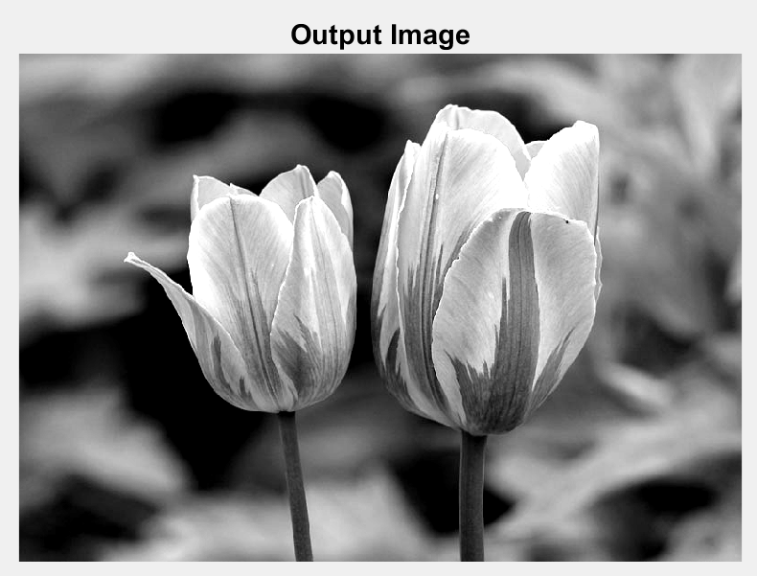

Figure 16: mage on the left is with histogram equalization, image on the right is with transformation a = 2, b = -110

The contrast in the equalized image is larger than the output image, and this can be observed through the brighter petals and darker stem in the equalized image. Although higher contrast allows the important features and edges in the picture to be highlighted, a lot of details are missing in the equalized image as shown in the red square. The petals in equalized image are also almost white, unlike in the output image which still have some darker shades. With some shade on the petals, observers can tell the depth of the object in the image.